The first thing that we are going to do is manage the user accounts and groups. This can be done by open the windows menu and then right click on computer and select manage.

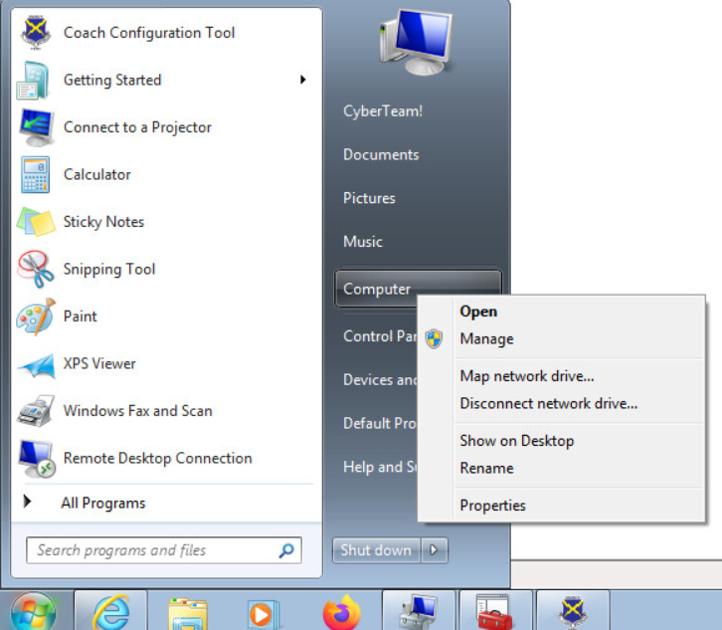

Then browse to Computer Configuration\System Tools\Local Users and Groups\Users and you should then see this screen.

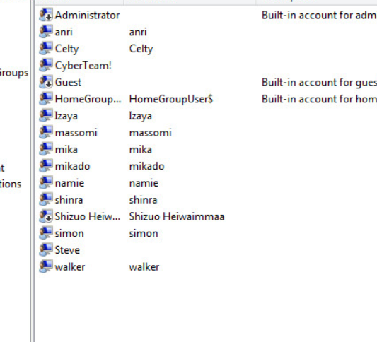

Then we want to doble click on the user account for Shizuo and uncheck the account is disabled box and click ok.

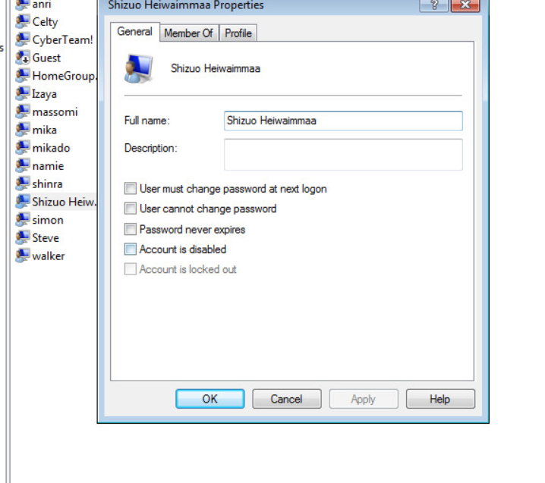

We are then going to reset his password by right clicking and selecting set password.

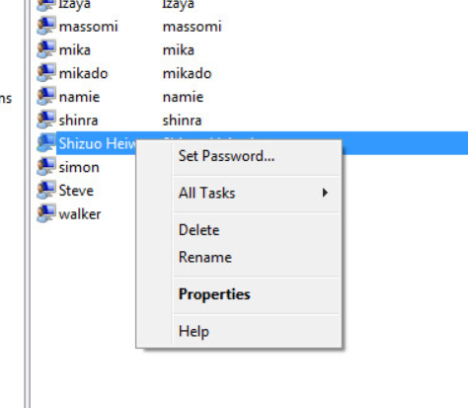

This warning screen will then open, and you should select proceed.

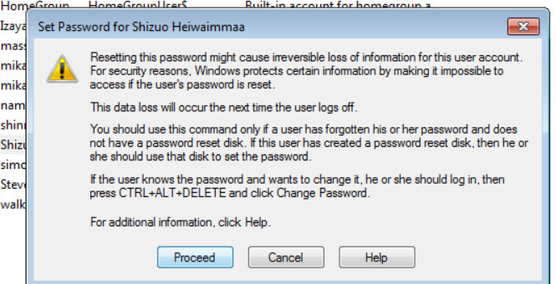

Then enter a password and confirm it and click ok.

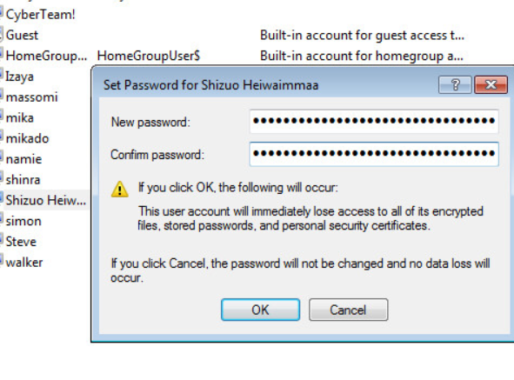

Now move to the Groups tab and we can see there is an extra group Dollars which should not be there. To remove it right click on it and select delete.

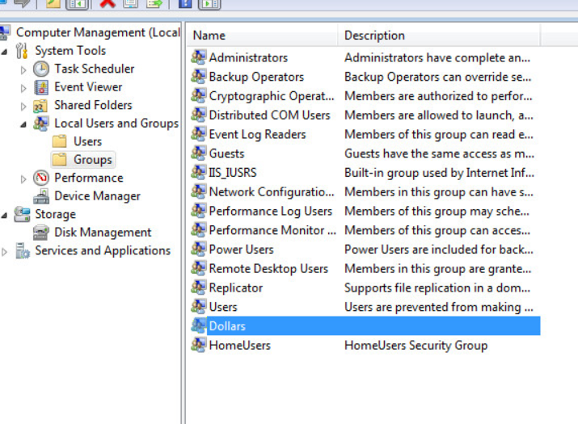

Then open the windows search bar and click on control panel.

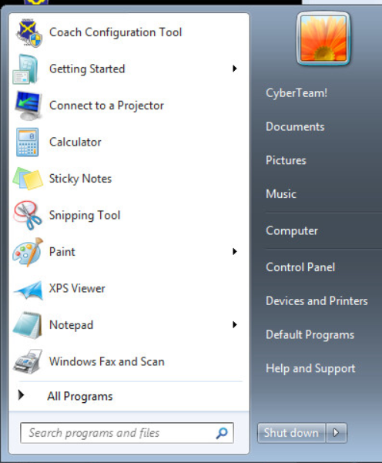

Then on this screen click on uninstall a program.

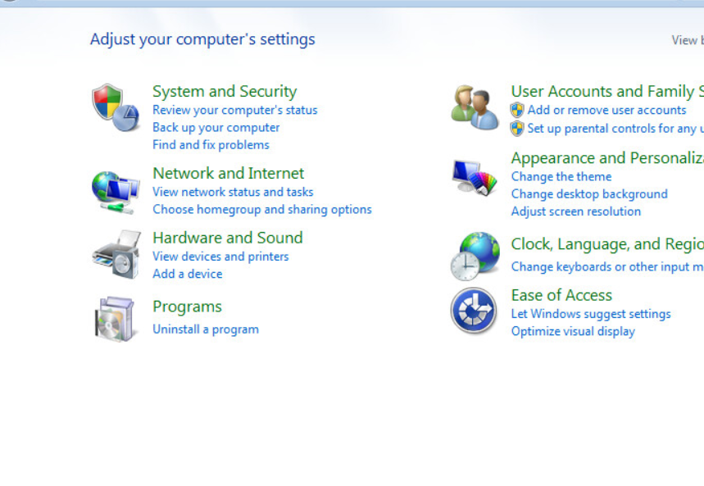

Then we are going to delete the CCleaner and steam programs by selecting one at a time and clicking uninstall/change and waiting for them to uninstall. 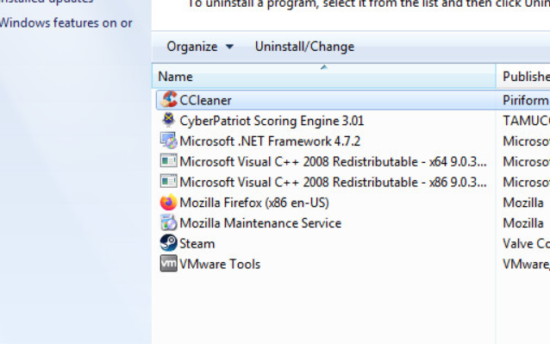

Then click on turn windows feature on or off and look under games to turn solitaire off then under Media Features uncheck windows dvd maker then click ok and wait for the feature to be removed.

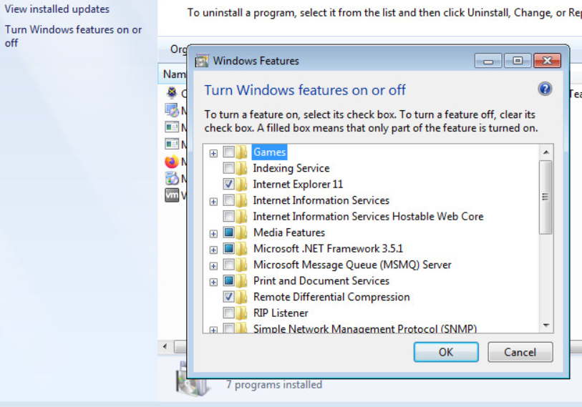

Now we are going to open the Microsoft management console which can be done by searching for mmc in the search bar.

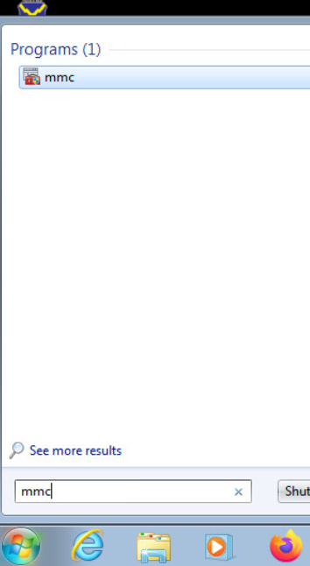

Next, we need to add a snap in within the console we just opened, this can be done by clicking on file then add/remove snap in.

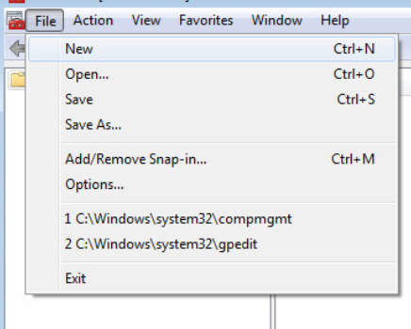

We are going to add the group policy object snap in so highlight it by clicking on it in the list on the left then click the add button then finally the ok button.

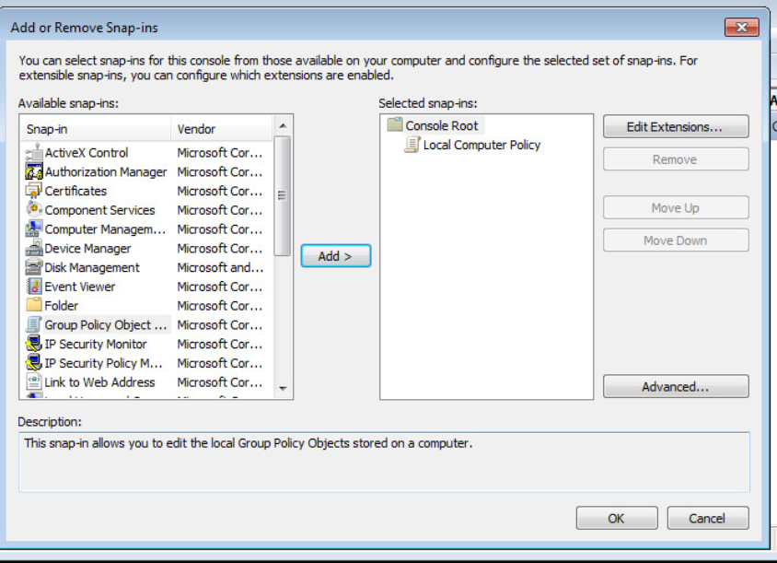

Then browse to Computer Configuration\Windows Settings\Security Settings\Local Policies\Security Options. Now find the setting Network access: Do not allow anonymous enumeration of SAM accounts and shares and set it to enabled.

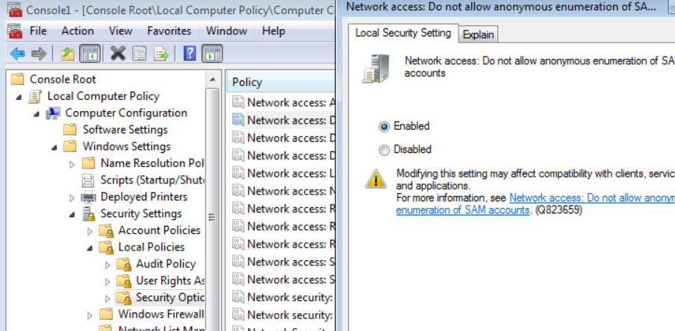

Then look for the User account control setting for behavior of the elevation prompt for administrators in approval mode and set it to prompt for credentials.

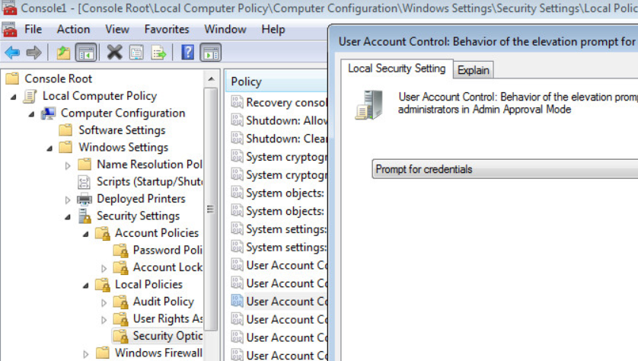

Now browse to Computer Configuration\Windows Settings\Security Settings\Account Policies\Account lockout policy. Then find the reset account lockout timer after setting and change it to 15 minutes.

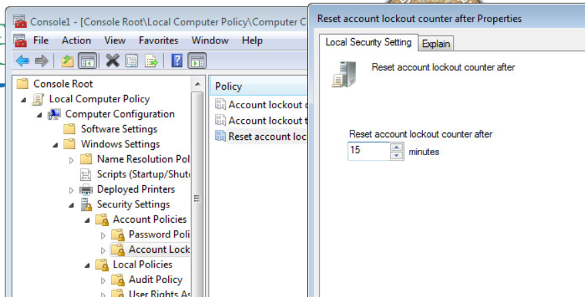

Then change to the Password Policy section and set the minimum password age to 5 days.

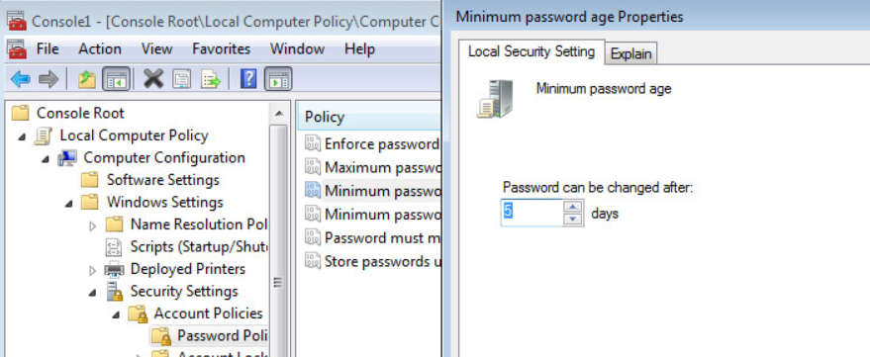

Now search for update and open the windows updates.

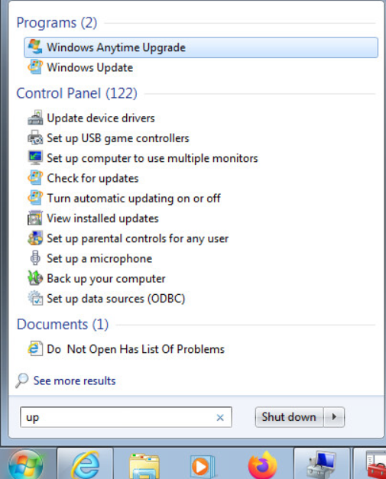

You should then see a screen like this, now click turn on automatic updates.

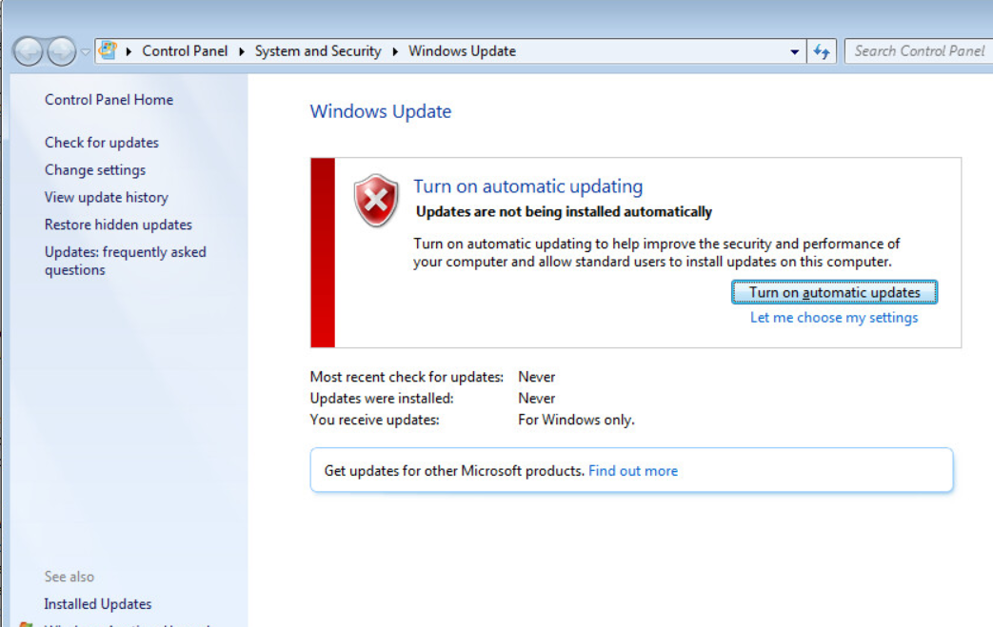

Now open up the task scheduler by searching for it.

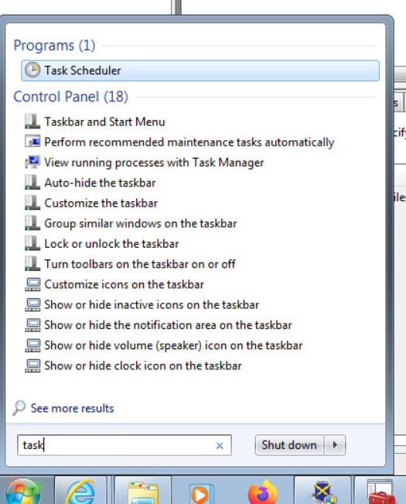

Then go to the task scheduler library, there is an odd-looking task called NewTask that runs a bat script every 15 minutes. Take note of the location of the script and delete the task by right clicking on it and selecting delete.

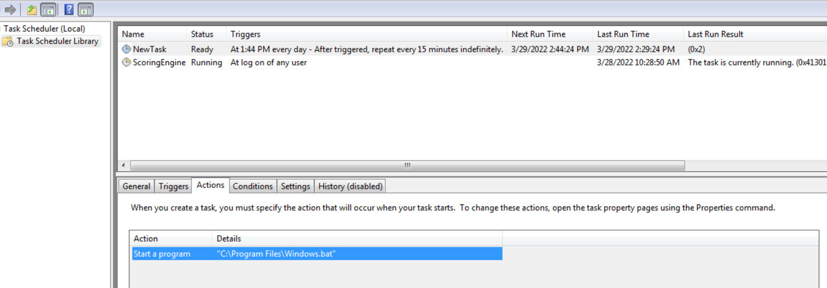

Now open up the file explorer by opening the windows menu and clicking on Computer.

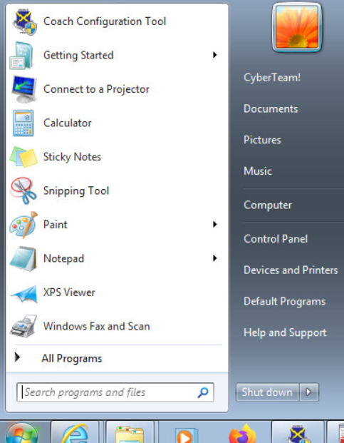

You should then see a window like this, now we are going to browse to where the script was stored at which was C:/program files

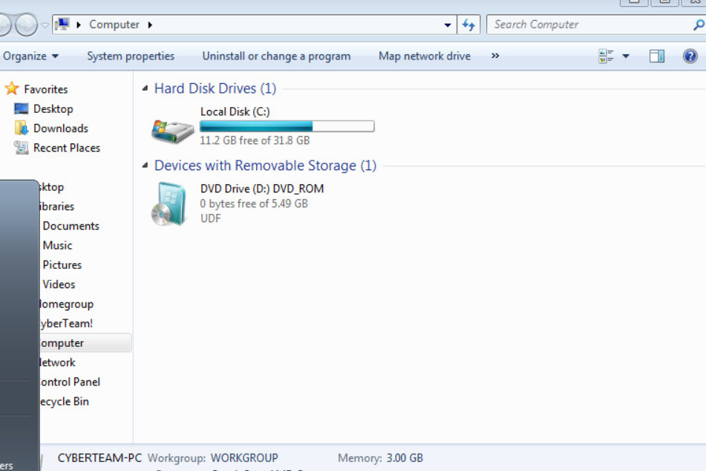

You should then be able to find the script and if we look at what it is doing it is adding a user so we want to delete it.

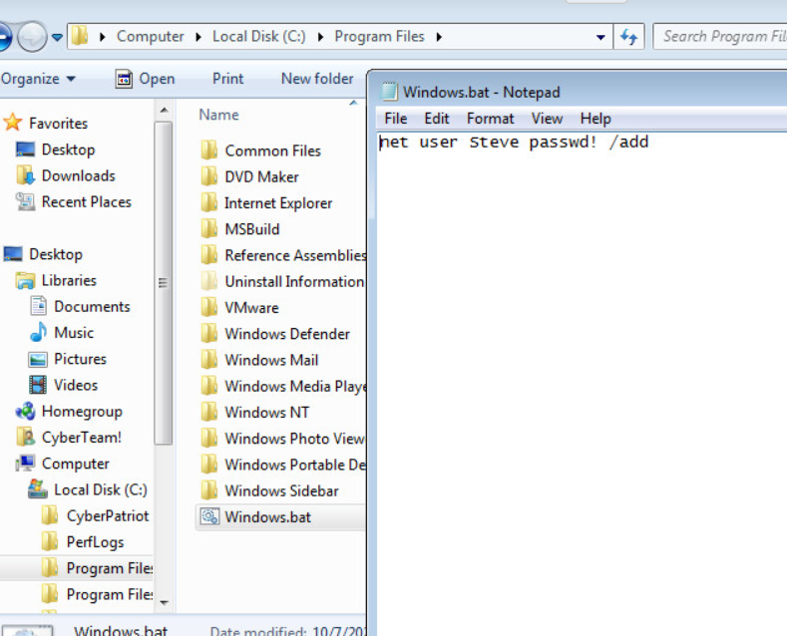

Now we are going to look for unauthorized media files one way to do this is to use the file explorer window we just opened and go back to the C drive. Then search using the wild card \* with media file extensions.

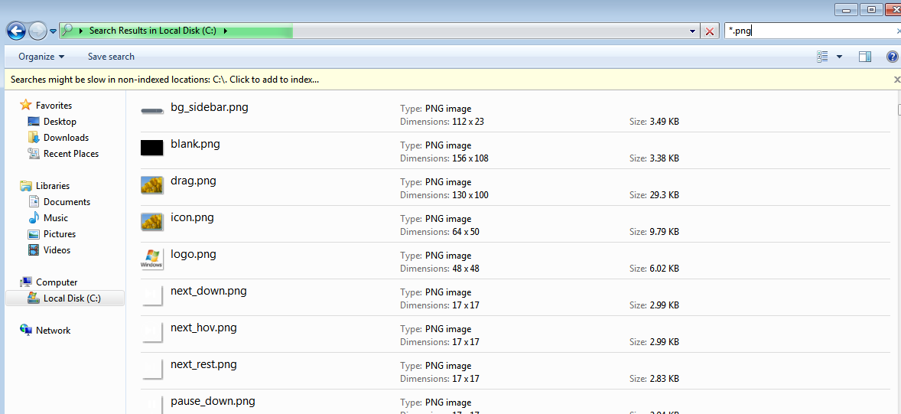

You can then right click on an empty spot of the window and change it so that files are sorted by date.

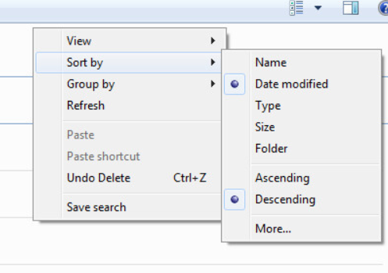

Looking through this list the file art.png looks out of place if you right click on it and opeen the file location it takes you to an unauthorized users pictures folder.

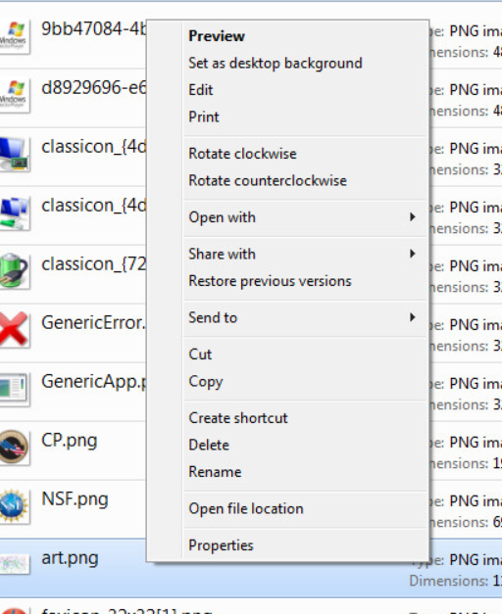

Notice that the user Izaya was not in the list of permitted users in the readme and the file does not seem to be needed.

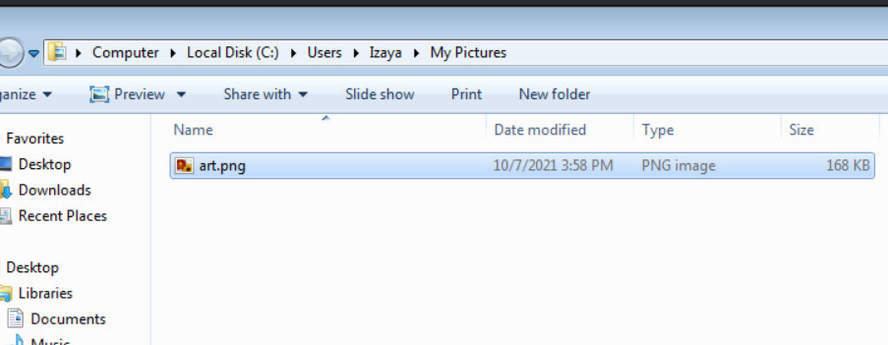

When looking at the picture we can definitely see that it is not needed and can be deleted.

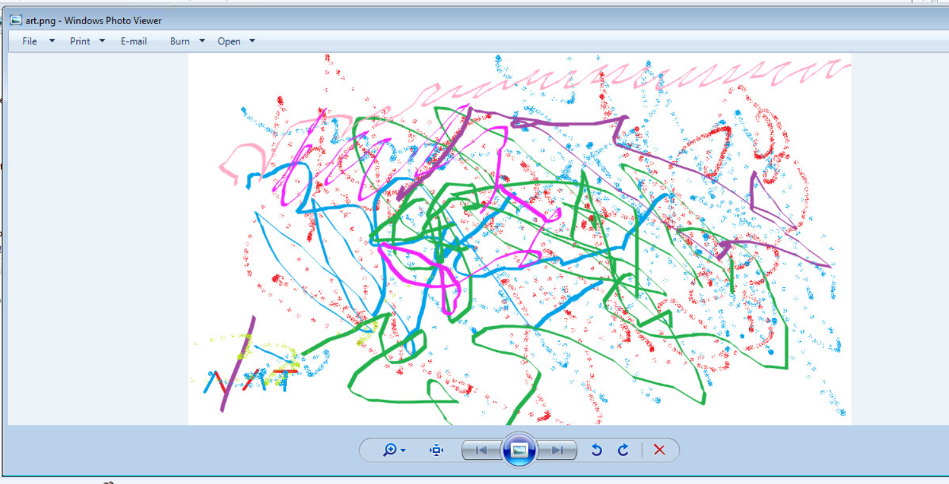

After deleting the files you may need to empty the recycle bin which can be done by right clicking the recycle bin and selecting empty.

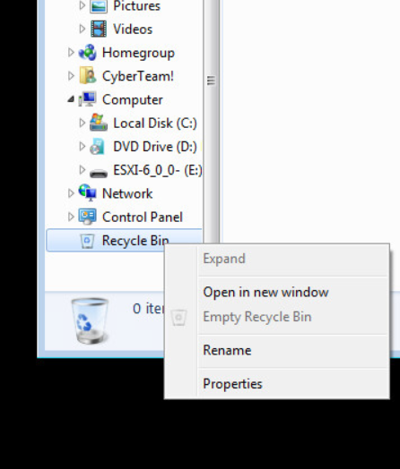

Now we are going to check on the status of windows defender by opening it with the windows search menu.

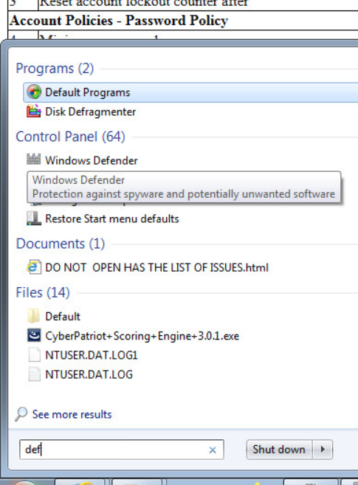

You should then see this screen so we want to enable windows defender by clicking on the link that says click here to turn it on.

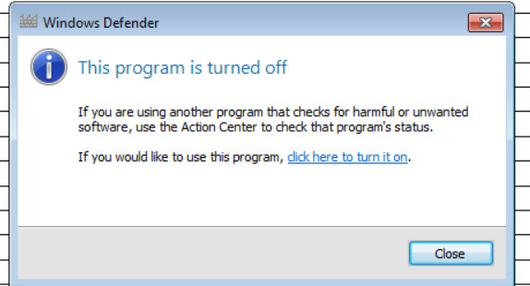

This is what the score report should look like after all scored vulnerabilities have been properly addressed

